Add : 467 Hai Ba Trung, Hoi An, Vietnam

Tel: +84 2353917779

Fax: +84 989805179
Email:booking@goldenholidayhoianhotel.

com

Website : www.goldenholidayhoianhotel.com

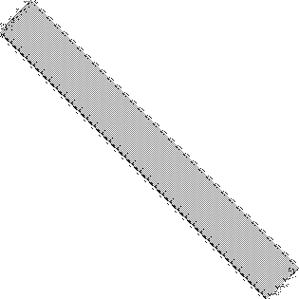

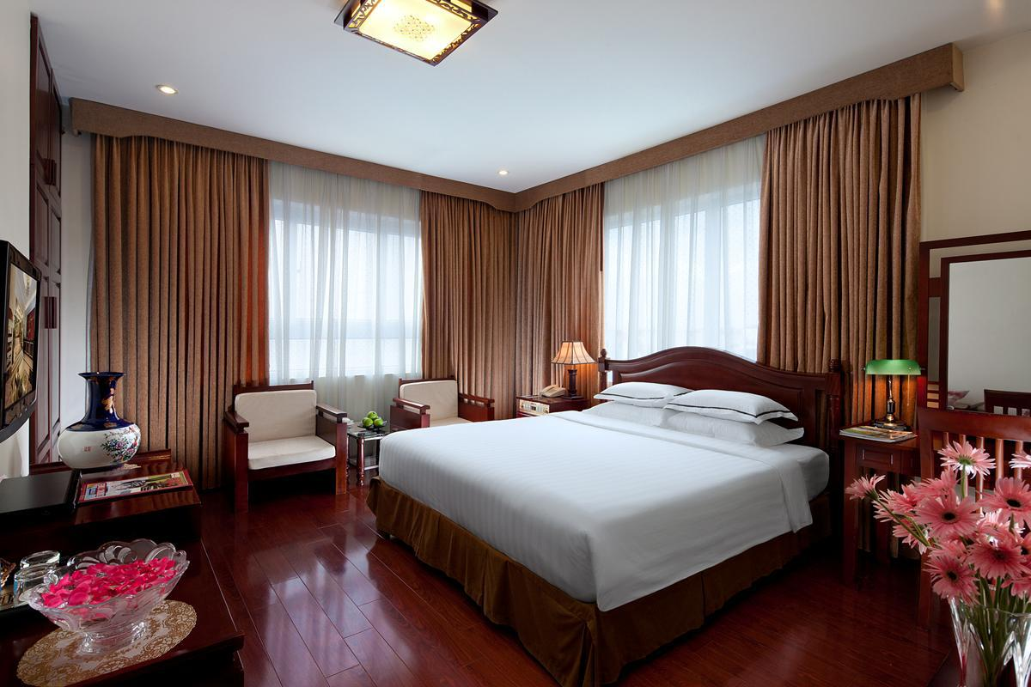
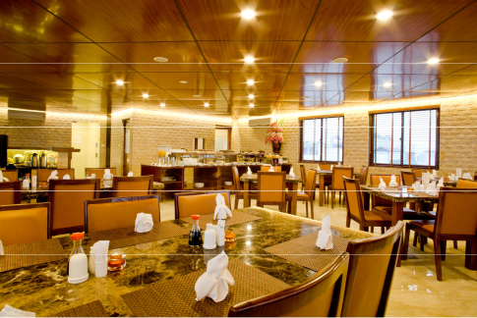
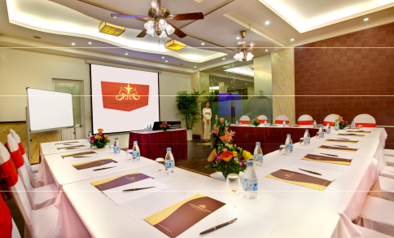
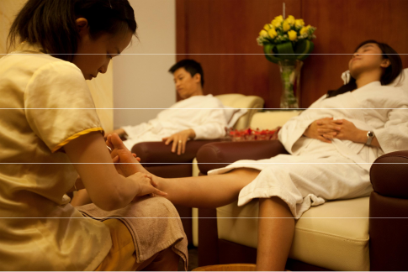

HOTEL FACT SHEET

Our executive location, right in the heart of Hanoi, brings Hoan Kiem Lake seemingly to your doorstep. It is splendidly located on one of the renowned 36 ancient streets, within walking distance to all the main attractions as restaurants, bars, shopping & business centers, sightseeing venues & entertainment. The hotel offers the best convenience to explore the beauty of boutique Hanoi.








With 40 spacious luxurious guest rooms, fully renovated with an exquisite mix of antiques and up to date furniture and fixtures, the Hanoi Imperial Hotel provides the ultimate accommodation and comfort; a magnificent view of Hoan Kiem Lake and stunning city’s life. It allows you to capture fantastic images and also have quiet rest at bed time.

Stay at Hanoi Imperial Hotel; enjoy the most comfortable atmosphere and an ambiance of elegance. We take you home away from home through the honesty, hospitality and professional in service.

Whether you are a tourist or here on business, Hanoi Imperial Hotel is a truly great place to stay.

IMPERIAL HOTEL – Proud for providing:

The best location: centrally located in the Old Quarter, 3minutes to Hoankiem Lake, 10 minutes by car to famous spots as Hochiminh Mausoleum Complex, One Pillar Pagoda, Temple of Literature, Westlake, Tran Quoc Pagoda...
The best accommodation: dining restaurant, well equipped B.C, souvenir shop, luxurious rooms with windows, full of modern facilities and up to date amenities...
The best hospitality: professionalism, enthusiasm, honesty and well trained staff. Our motto is “listening to customer is the best way of development”.
The best benefits to the partners: our cooperation policies will bring you the highest profit in order to build up the target partnership for a sustainable development.

RESERVATION

The reservations can be made directly to the hotel via:


1. RESERVATION: Tel : (+84)4.39335555 Fax: (+84)4.39381315
Email : sales@hanoiimperialhotel.com

Confirmation or acknowledgment of the reservation will be made within 24 hours.

Credit card details, including credit card type, number,

2.GUARANTEE: cardholder’s name and expiry date should be provided for guarantee. Non – guaranteed booking will be held till 14:00 on arrival date.

Cancellation can be made 72 hours before the arrival date

- CANCELLATION:without charge. Late cancellation or no – show (unless specific mentioned in confirmation or contact) will be charged at 100% of the accommodation fee for the first night, the balance is automatically released.

Account name : Thien Phu Tourist.,JSC (Cong ty co phan
4. BANKING DETAILS:
du lich dich vu thuong mai Thien Phu)


Account No : VND : 116000083616

USD : 116000201313

Bank name: VietinBank-Vietnam Joint Stock

Commercial Bank for Industry and Trade

A copy of the bank transfer needs to be forwarded to Hanoi Imperial Hotel when it is being sent. Please note that transfers typically take 2 weeks.

Contract agreement will be made to provide the best

5. CONTRACT : prices and benefits for the agents. Commission in contract could be maximized to 30% on the room rates.

ROOM DESCRIPTION :


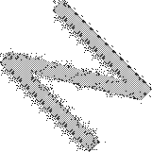













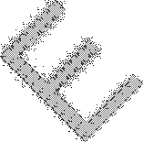

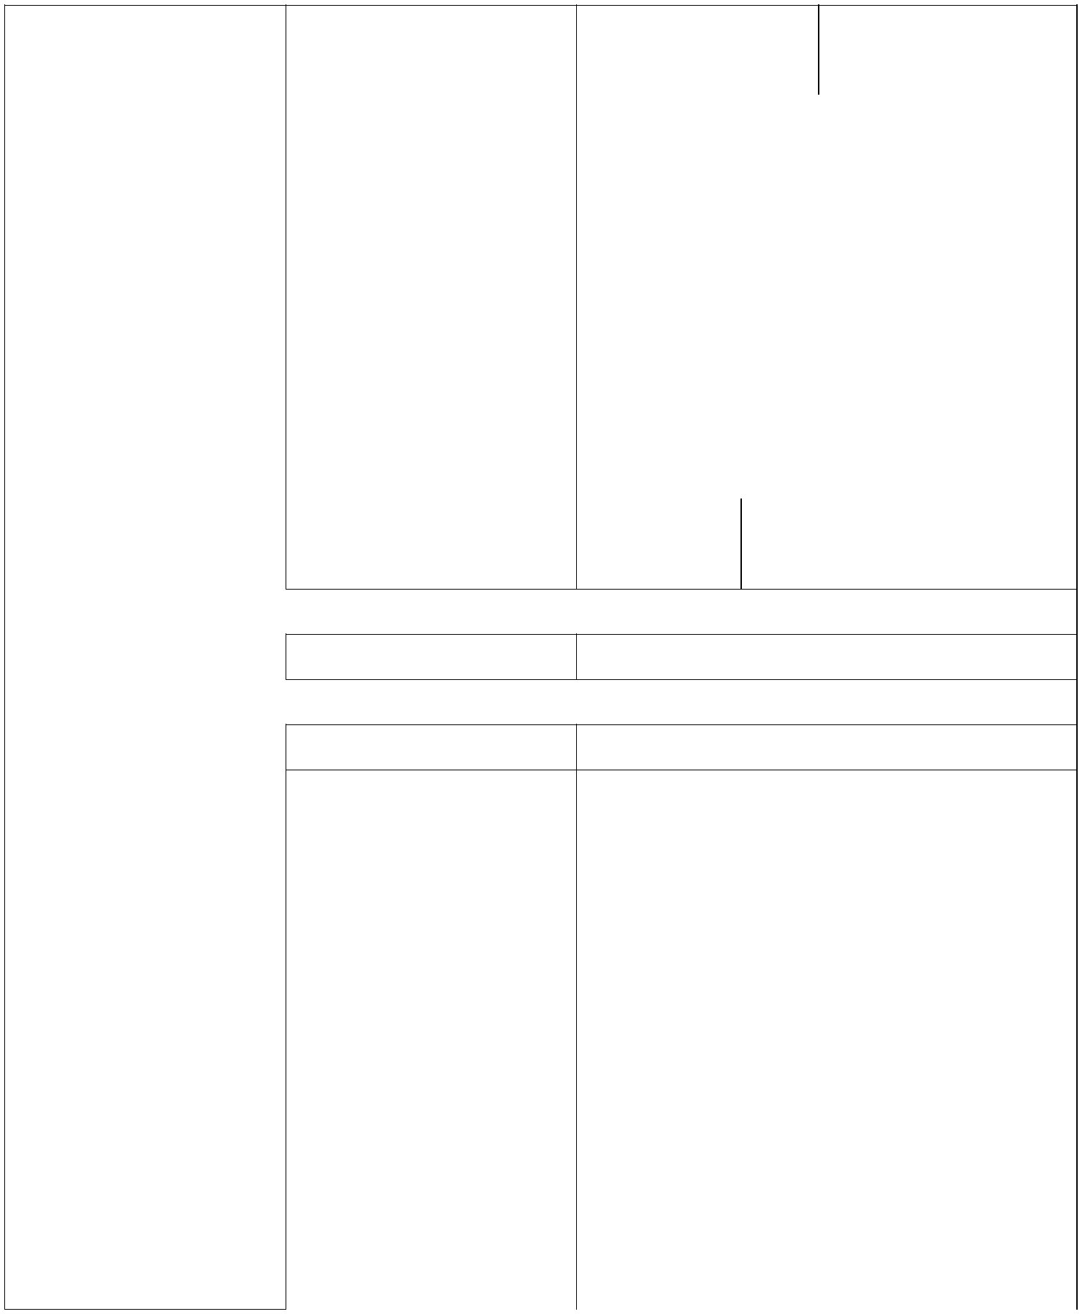

SUPERIOR | - Capacity: Max 02 pax |  | Quanity: 05 rooms Room size: 25 sqm
NO WINDOW |  |  | ( DBL: 05)
 | - Room location |  | ✓ From 02 ^{nd} to 03 |  |  |  |  | ^{th} floor
 | - Bed size |  | ✓ 1.6 x 1.8
 | - Extra bed |  | ✓ No
 | - Baby cot |  | ✓ Yes with FOC . Max FOC baby cot in a
 |  |  | room: 01
 | - Window |  | ✓ No
 | - View |  | ✓ No
 | - Balcony |  | ✓ No
 | - No smoking room |  | ✓ Yes
 | - Bathroom |  | ✓ Yes |  |  | ✓ Hot water central
 |  |  |  |  |  | ✓ Bath robe

- Wireless Internet
- Cable Internet

- Daily mineral water
- Fruits

✓ Complimentary
✓ Complimentary

✓ Yes
✓ Yes for 01 ^{st} arrival

- | Daily newspaper | ✓ Yes at the lobby
- | Air conditioner |  | ✓ Yes
- | LCD Satellite |  | ✓ Yes with 65 international channel
- DVD player |  |  | ✓ Yes
- | Private safety box |  | ✓ Yes
- Working desk |  |  | ✓ Yes
- | Minibar |  | ✓ Yes
- | Kettle |  | ✓ Yes
- | Hair Dryer |  | ✓ Yes
- Tea & coffee facilities |  |  | ✓ Yes
- | Automatically |  | ✓ Yes
 | electric controller.







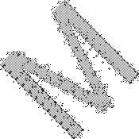

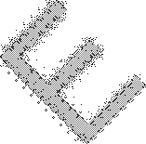







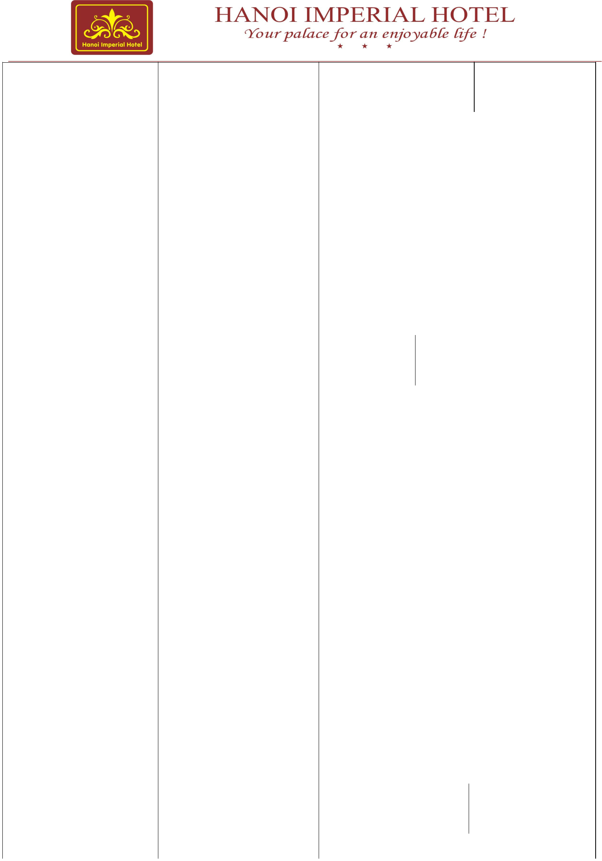
SUPERIOR WITH |  | Capacity: Max 02 pax |  |  |  | Quanity: 05 rooms |  |  |  |  |  |  | Room size:
WINDOW |  |  |  |  |  | ( DBL: 02, TWN: 03) |  |  |  |  |  |  | 25 sqm
 |  |  | - Room location |  |  | ✓ From 02 ^{nd} to 03th floor
 |  |  | - Bed size |  |  | ✓ 1.6 x 1.8
 |  |  | - Extra bed |  |  | ✓ No
 |  |  | - Baby cot |  |  | ✓ Yes with FOC. Max FOC baby cot in a
 |  |  |  |  |  | room: 01
 |  |  | - Window |  |  | ✓ Yes
 |  |  | - View |  |  | ✓ City view
 |  |  | - Balcony |  |  | ✓ No
 |  |  | - No smoking room |  |  | ✓ Yes
 |  |  | - Bathroom |  |  | ✓  Yes |  |  | ✓ Hot water central
 |  |  |  |  |  |  |  |  | ✓ Bath robe
 |  |  | - | Wireless Internet |  | ✓ Complimentary
 |  |  | - | Cable Internet |  | ✓ Complimentary
 |  |  | - | Daily mineral water |  | ✓ Yes
 |  |  | - | Fruits |  | ✓ Yes for 01 ^{st} arrival
 |  |  | - | Daily newspaper |  | ✓ Yes at the lobby
 |  |  | - | Air conditioner |  | ✓ Yes
 |  |  | - | LCD Satellite |  | ✓ Yes with 65 international channel
 |  |  | - DVD player |  |  | ✓ Yes
 |  |  | - | Private safety box |  | ✓ Yes
 |  |  | - Working desk |  |  | ✓ Yes
 |  |  | - | Minibar |  | ✓ Yes
 |  |  | - | Kettle |  | ✓ Yes
 |  |  | - | Hair Dryer |  | ✓ Yes
 |  |  | - Tea & coffee facilities |  |  | ✓ Yes
 |  |  | - | Automatically |  | ✓ Yes
 |  |  |  | electric controller.
DELUXE ROOM |  |  | Capacity: Max 02 pax |  |  | Quanity: 20 rooms |  |  |  |  |  |  | Room size:
WITH WINDOW |  |  |  |  |  | ( DBL: 08, TWN: 12) |  |  |  |  |  |  | 30 sqm
 |  |  | - Room location |  |  | ✓ From 03 ^{nd} to 08th |  |  |  |  | floor



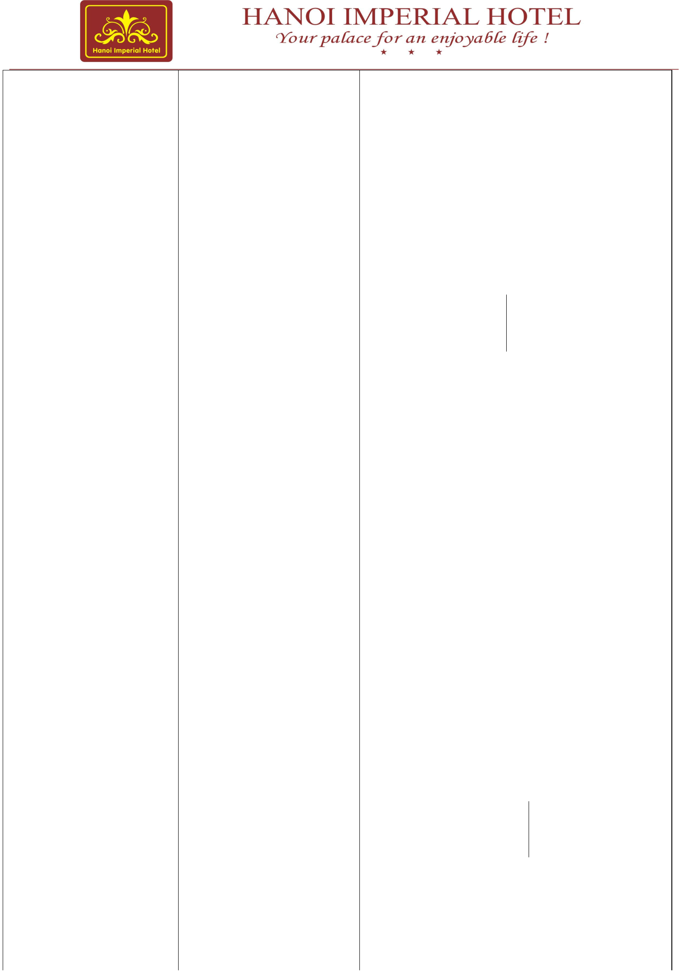
 |  | - Bed size |  |  | ✓ 1.6 x 1.8
 |  | - Extra bed |  |  | ✓ Yes
 |  | - Baby cot |  |  | ✓ Yes with FOC | Max FOC baby cot in
 |  |  |  |  | a room: 01
 |  | - Window |  |  | ✓ Yes
 |  | - View |  |  | ✓ City view
 |  | - Balcony |  |  | ✓ Yes for 02 double rooms
 |  | - No smoking room |  |  | ✓ Yes
 |  | - Bathroom |  |  | ✓  Yes |  |  | ✓ Hot water central
 |  |  |  |  |  |  |  | ✓ Bath robe
 |  | - | Wireless Internet |  | ✓ Complimentary
 |  | - | Cable Internet |  | ✓ Complimentary
 |  | - | Daily mineral water |  | ✓ Yes
 |  | - | Fruits |  | ✓ Yes for 01 ^{st} arrival
 |  | - | Daily newspaper |  | ✓ Yes at the lobby
 |  | - | Air conditioner |  | ✓ Yes
 |  | - | LCD Satellite |  | ✓ Yes with 65 international channel
 |  | - DVD player |  |  | ✓ Yes
 |  | - | Private safety box |  | ✓ Yes
 |  | - Working desk |  |  | ✓ Yes
 |  | - | Minibar |  | ✓ Yes
 |  | - | Kettle |  | ✓ Yes
 |  | - | Hair Dryer |  | ✓ Yes
 |  | - Tea & coffee facilities |  |  | ✓ Yes
 |  | - | Automatically |  | ✓ Yes
 |  |  | electric controller.
IMPERIAL ROOM |  | Capacity: Max 02 pax |  |  | Quanity: 04 rooms |  |  |  |  | Room size:
 |  |  |  |  | ( DBL: 02, TWN: 02) 35 sqm
 |  | - Room location |  |  | ✓ From 04 ^{nd} to 07th |  |  |  |  | floor
 |  | - Bed size |  |  | ✓ 1.6 x 2.0
 |  | - Extra bed |  |  | ✓ Yes
 |  | - Baby cot |  |  | ✓ Yes with FOC . Max FOC baby cot in a

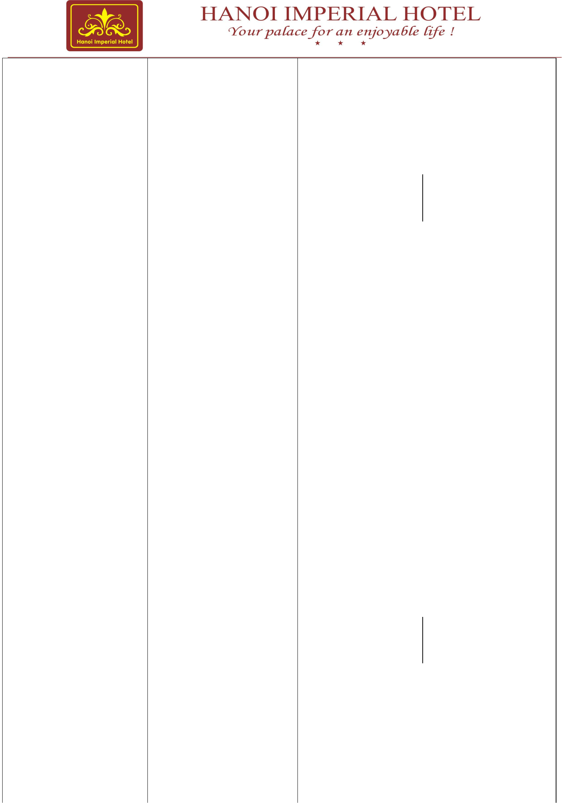
 |  |  |  |  | room: 01
 |  | - Window |  |  | ✓ Yes, 02 big windows
 |  | - View |  |  | ✓ City view
 |  | - Balcony |  |  | ✓ No
 |  | - No smoking room |  |  | ✓ Yes
 |  | - Bathroom |  |  | ✓  Yes |  |  | ✓ Hot water central
 |  |  |  |  |  |  |  | ✓ Bath robe
 |  | - | Jacuzzi |  | ✓ Yes
 |  | - | Wireless Internet |  | ✓ Complimentary
 |  | - | Cable Internet |  | ✓ Complimentary
 |  | - | Daily mineral water |  | ✓ Yes
 |  | - | Fruits |  | ✓ Yes for 01 ^{st} arrival
 |  | - | Daily newspaper |  | ✓ Yes at the lobby
 |  | - | Air conditioner |  | ✓ Yes
 |  | - | LCD Satellite |  | ✓ Yes with 65 international channel
 |  | - DVD player |  |  | ✓ Yes
 |  | - | Private safety box |  | ✓ Yes
 |  | - Working desk |  |  | ✓ Yes
 |  | - | Minibar |  | ✓ Yes
 |  | - | Kettle |  | ✓ Yes
 |  | - | Hair Dryer |  | ✓ Yes
 |  | - Tea & coffee facilities |  |  | ✓ Yes
 |  | - | Automatically |  | ✓ Yes
 |  |  | electric controller.
FAMILY ROOM |  | Capacity: Max 03 pax |  |  | Quanity: 06 rooms |  |  | Room size: 43 sqm
 |  | - Room location |  |  | ✓ From 02 ^{nd} to 06 |  |  | ^{th} floor
 |  | - Bed size |  |  | ✓ 1.6 x 1.8 and 1.2 x 1.8
 |  | - Extra bed |  |  | ✓ Yes
 |  | - Baby cot |  |  | ✓ Yes with FOC. Max FOC baby cot in a
 |  |  |  |  | room: 01
 |  | - Window |  |  | ✓ Yes

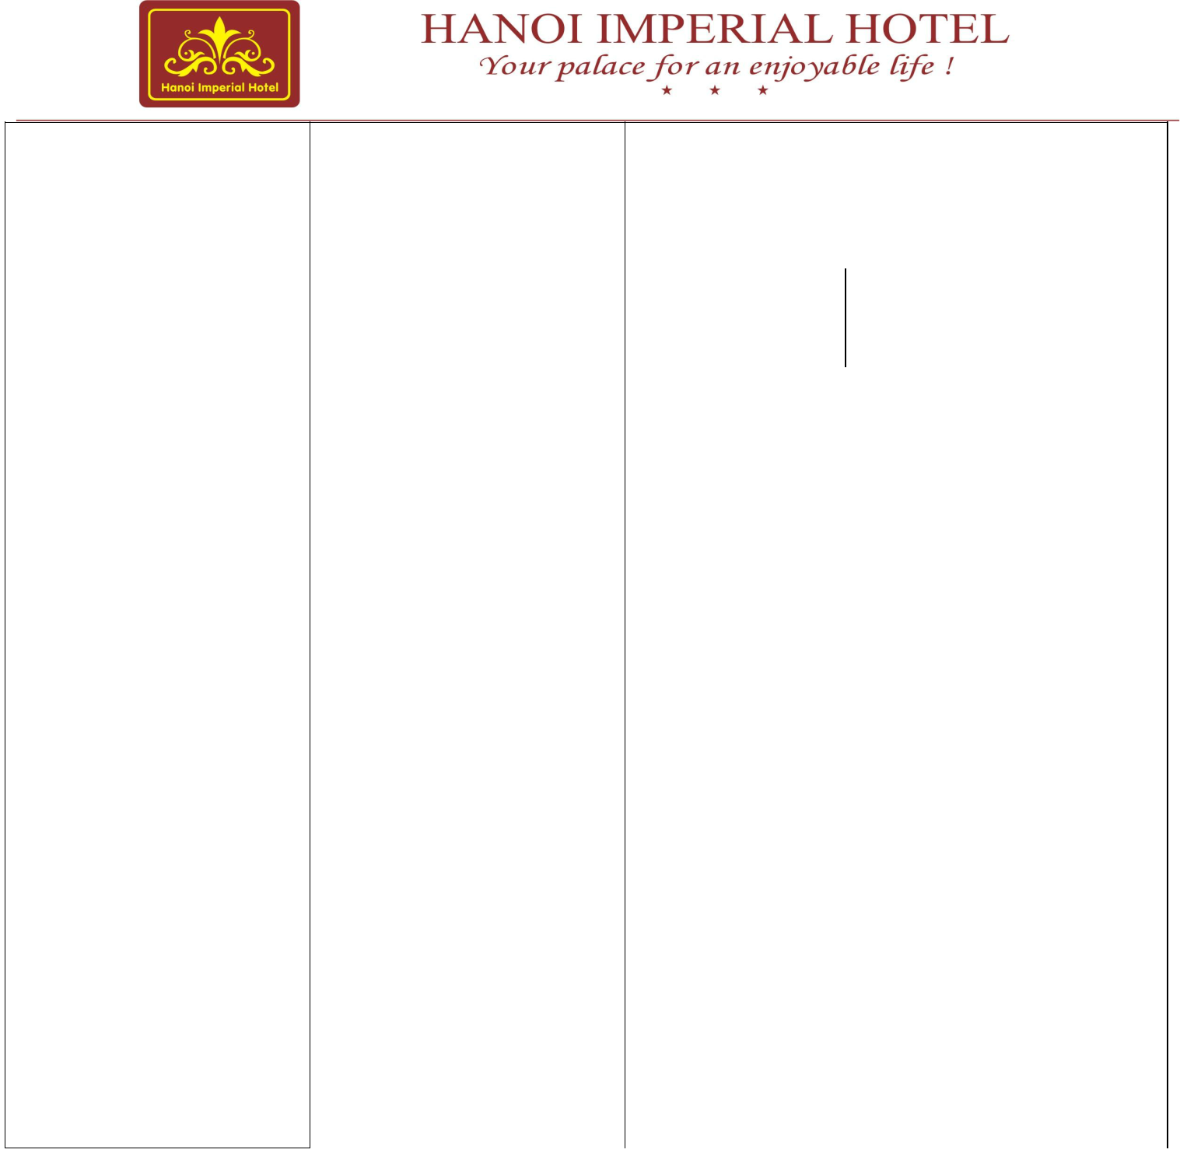
- View |  |  | ✓ City view
- Balcony |  |  | ✓ No
- No smoking room |  |  | ✓ Yes
- Bathroom |  |  | ✓  Yes |  | ✓ Hot water central
 |  |  |  |  | ✓ Bath robe
- | Wireless Internet |  | ✓ Complimentary
- | Cable Internet |  | ✓ Complimentary
- | Daily mineral water |  | ✓ Yes
- | Fruits |  | ✓ Yes for 01 ^{st} arrival
- | Daily newspaper |  | ✓ Yes at the lobby
- | Air conditioner |  | ✓ Yes
- | LCD Satellite |  | ✓ Yes with 65 international channel
- DVD player |  |  | ✓ Yes
- | Private safety box |  | ✓ Yes
- Working desk |  |  | ✓ Yes
- | Minibar |  | ✓ Yes
- | Kettle |  | ✓ Yes
- | Hair Dryer |  | ✓ Yes
- Tea & coffee facilities |  |  | ✓ Yes
- | Automatically |  | ✓ Yes
 | electric controller.

